E N G L I S H F O R

L O G I S T I C S
(delovno gradivo)

Ljubljana, 2014 Vida Mrkun

1. INTRODUCTION TO LOGISTICS
Logistic or logistical means relating to the organization of something complicated .
Logistics If you refer to the logistics of doing something complicated that involves a lot of people or equipment, you are referring to the skilful organization of it so that it can be done succesfully and efficiently.

Some definitions of logistics
1. Logistics means that you manage the procurement and movement of goods and the storage of inventory.
2. It means the delivery of goods the customer needs at the right time, in the right place, and of the right quality.
3. Logistics means to plan, organize, and manage operations that provide services and goods.
4. Logistics – that`s the purchasing, maintenance, distribution, and replacement of material and staff.
5.Logistics is the planning and support of operations such as warehousing,
inventory, transport, procurement, supply, and maintenance, support.

Logistics describes the organized movement of physical materials in a factory. It is usually subdivided into materials management, which is control of the efficient and effective flow of materials in the factory, from the arrival of raw materials to the packaging of the product, and distribution management, which includes the storage of goods and their transportation to distributors and consumers.
At the same time, efficient logistics needs efficient documentation (bill of lading, delivery note, envelope, packing list, picking list) flow for the goods (cargo, consignment, freight, shipment) from storage (depot, distribution centre, forklift truck, pallet, warehouse) to destination. The process of distribution (carriage, carrier, chanell, deliver, delivery, dispatch, export, forward haul,import, in transit, lading, load, shipper, unload) involves different means of transportation ( air freight, lorry, ship, tanker, truck, van) and requires secure packaging ( carton,crate, pack, package).
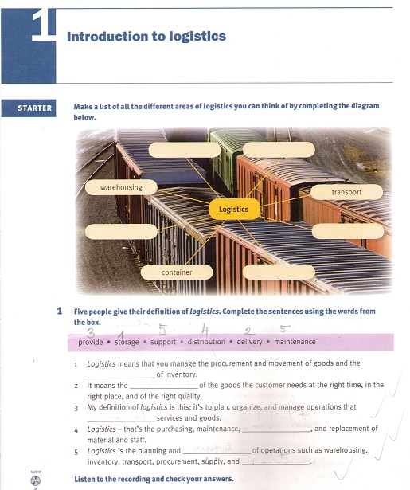

2. JOBS IN LOGISTICS
Freight forwarder
His job is to organize the transport of goods either by sea, air, road, or rail. An important part of his job is dealing with customers requests about the most suitable mode of transport. His responsibilities also include negotiating good shipping rates with shipping lines and transport companies. He also arranges customs clearance on behalf of his clients.
Shipping operations manager
He has to make sure that the cargo is not damaged onboard the ship or while loading or unloading. He advices customers on shipping rates and prepare quotations for the sales office.
Warehouse manager
His job is to liaise with departments such as transport and production. He ensures that vehicles, machines, and any other kinds of equipment are maintained to a high level.
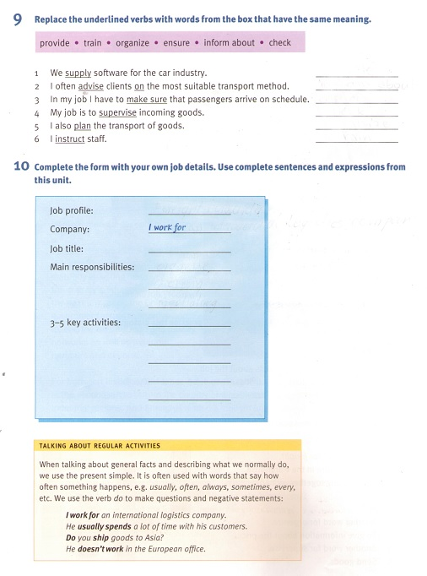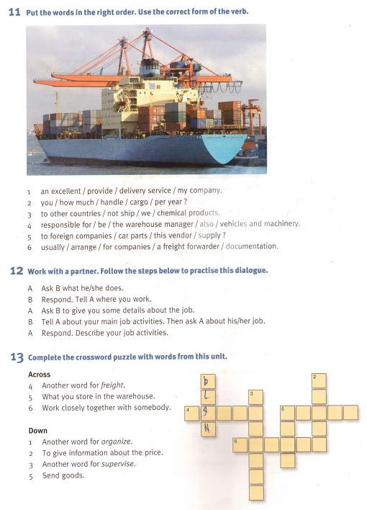

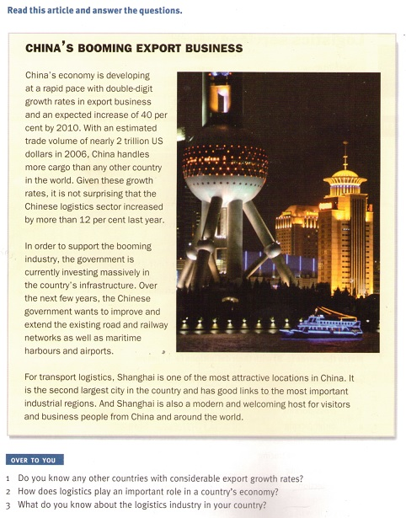
LOGISTICS ACRONYMS AND PHRASES
FCL full container load GPS Global Positioning System
HGV heavy goods vehicle LCL less than container load
DC distribution centre 3PL third- party logistic
ISO International Standards Organization
EDI electronic data interchange VAS value-added services
RFID radio frequency identification

Definitions of some phrases.
transshipment- loading goods from one means of carriage onto another
break-bulk - packing goods in small, separable units
cross-docking - direct flow of goods from receipt at warehouse to shipping,
bypassing storage
order picking - selecting and assembling items from stock for shipments
reverse logistics collecting and handling of used or damaged goods or of
reusable transit equipment
tracking and tracing - locating items in transit
warehousing - receiving and storing goods
collection - picking up goods at a named place

Three logistics providers and their services
Provider 1 (GFT Global carrier) specializes in solutions for full container loads and less than container consolidated freight. Transport mode: sea
Provider 2 (Home tex International) specializes in home textiles.
Transport mode: road
Provider 3 (Cargo express) specializes in consolidated air freight forwarding.
Transport mode: air

4. INVENTORY MANAGEMENT AND PROCUREMENT
Key terms
Economies of scale : reducing costs per unit by increasing production
Buffer stock : goods kept in store to cover unforeseen shortages or fluctuations in demand
Factory gate pricing : transport costs are not included in the purchase price of
product
Supply chain : the close co-operation of all parties involved in the making,
selling and delivering of a product
Tender : an offer for goods or services that follows request for a quotation
made by an official body.e.g. local government
Lead time: is the time it takes to produce and supply a product
Procurement: is the purchasing of goods (materials, parts, supplies, equipment)
required to run an enterprise.
A retailer : is a business that buys producs from wholesalers or
manufacturers and resells them to the ultimate consumer.
Costumer order cycle time: is the time customers are prepared to wait for the
delivery of their order.
A wholesaler : is an intermediary between manufacturers and retailers
which buys in large quantities and resells in smaller quantities.
JIT- just in time : is a concept of reducing inventories by co-ordinating
the delivery of materials just before they are needed.
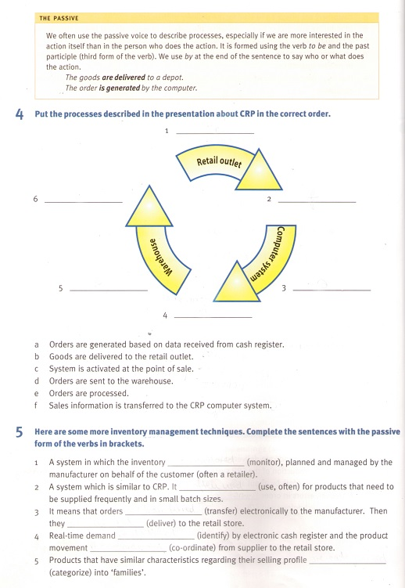

5. MODES OF TRANSPORT
The different types of freight traffic
Multimodal Carriage of goods by at least two different modes of transport,
e.g. shipping by motor lorry and aircraft.
Piggyback Combines road and rail transport: whole motor lorries,
trailers or swap-bodies are carried by rail.
Intermodal Goods are transported in the same loading unit or vehicle
using different modes of transport. The handling of the freight
itself is not necessary when changing modes.
Unaccompanied The driver does not stay with his road vehicle during
transport by rail or ferry.
Block train A single shipper uses a whole train which is run directly from
loading point to the destination. No assembling and
disassembling is required.
Single- wagon Train is formed out of individual wagons or sets of wagons
which have different origins and different destinations.
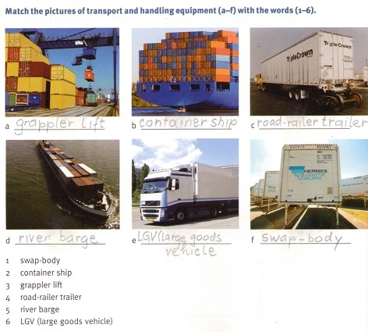

The descriptions of intermodal transport and handling equipment
GANTRY CRANE
A piece of machinery used for loading and unloading containers from ships onto trucks or rail wagons and vice versa. It is rail- mounted and can straddle at least four railway tracks. It is motorized and can move parallel to the ship`s side.
ISO CONTAINER
A special type of device which is able to handle very heavy loads. It is used for transferring swap-bodies and containers from rail wagons to trucks and vice versa. It has four legs fitted with wheels and a spreader beam which can span a wide area. It can be mounted on rails or rubber tyres and is able to straddle several rows of containers.

REACH STACKER
A kind of fork lift truck used in container handling. It is equipped with a spreader beam and a lifting arm and can be used for lifting containers and piling them on top of each other. It is very flexible and has a high stacking and storage capacity as it is able to reach beyond the first row of containers to lift a container.
TRANSTAINER
A rigid box made of steel which is very common in intermodal freight transport. It can be used for transport by sea, rail, air, and road. It is available in many different versions and sizes. For example, there are open-top and flat-rack versions . Some of them have wheels or a bogie attached to them. The most common lengths are 20, 40, and 45 feet. It is made to the specifications of the International Standards Organization.
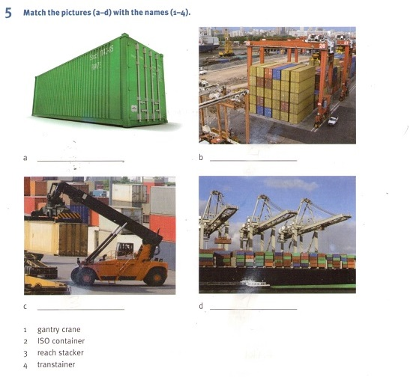
The different types of containers
REEFER CONTAINER It is suitable for transport of delicate cargo and perishables.
TANKTAINER It is suitable for transport of liquids.
OPEN-TOP CONTAINER It is suitable for transport of bulky cargo.
FLAT- RACK CONTAINER It is suitable for transport of heavy machinery and
pipes.
GENERAL PURPOSE CONTAINER It is suitable for transport of dry cargo.
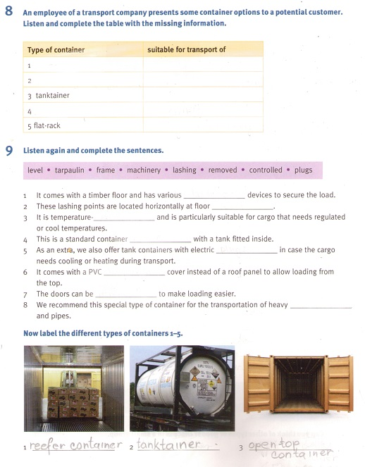

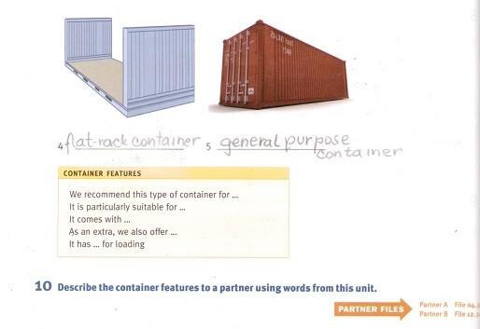

The different types of cargo
PERISHABLE CARGO: meat, fresh produce, seafood, dairy products, chilled
or frozen foodstuffs (reefer)
NON-PERISHABLE CARGO: crude oil,alcohol, harmful chemicals (tank container)
HEAVYWEIGHT AND OVERWIDTH CARGO : steel pipes, industrial boilers,
tractors (flat-rack container)
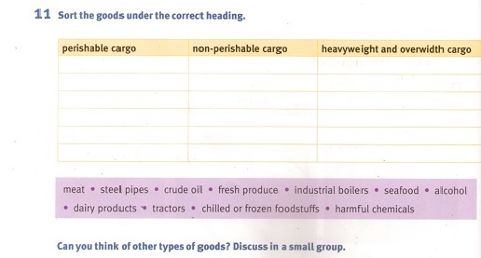
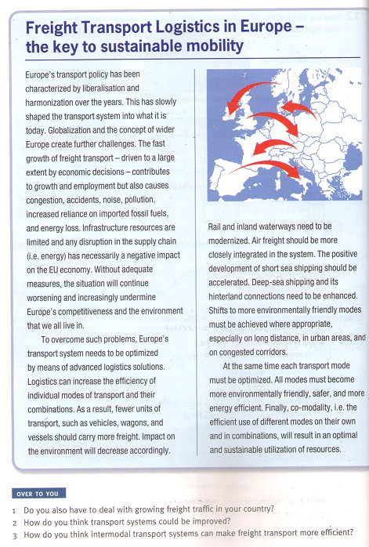

6. PLANNING AND ARRANGING TRANSPORT
The different factors that would influence the choice of transport for a shipment:
destination, value, weight, size, dimensions, type of goods, infrastructure, time factor, speed, urgency , nature of the goods, security
Abbreviations
ft foot kg kilogram oz ounce cm centimetre
lb pound cu yd cubic yard m2 square metre
1`` inch pt pint gal gallon
Description of the container:
Type of container: 40 ft open top
1.tare weight:
2. gross weight:
3. maximum payload:
Internal measurements:
4. length:
5. width:
6.height:
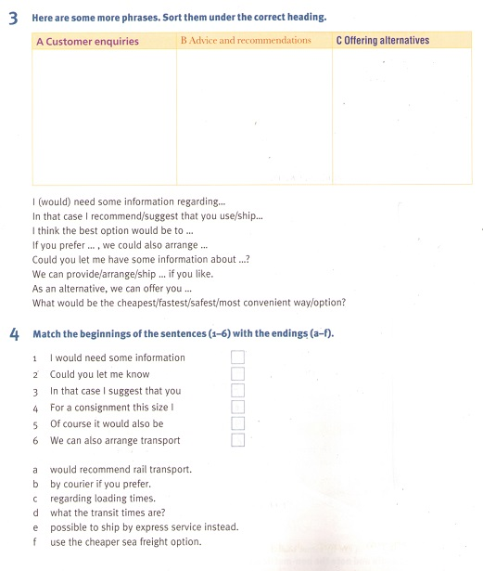

7. SHIPPING GOODS
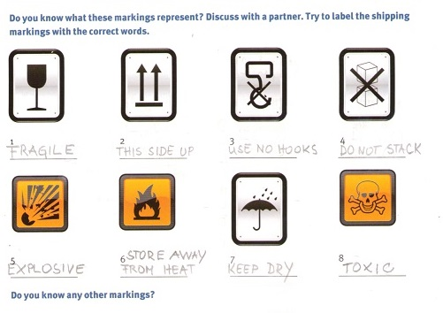

Rail loading instructions
Before loading:
1. Examine vehicle carefully.
2.Examine load carefully and make sure it is undamaged and suitable for loading.
3.Ensure vehicle is fit to be loaded.
4. When checking the vehicle , give special attention to door securing mechanisms.
During loading
1.Do not place items diagonally across the wagon.
2.Place longer, heavier pieces on the bottom of the load.
3.Strap overhanging loads.
4.Distribute load as evenly as possible and make sure wheels are evenly loaded.
After loading
1.When loading is complete, ensure that it fully complies with the instructions given in our Rail Instructions Manual.
2. Make sure that load is secure.
3. Examine vehicle and load carefully after loading.
4. Check whether vehicle capacity has not been exceeded.

Some kinds of packaging
Bale Large package of presspacked goods (often raw material), which is
tightly bound, wrapped , and banded.
Chest Sturdy box with a lid which is made of metal and often used for storage.
Barrel/cask Large cylindrical container with a flat bottom and top. It is made
of wood and is used for liquids.
Drum Cylindrical metal container for liquids.
Crate Wooden box made of wooden slats. It can be open or closed and is used for packing goods.
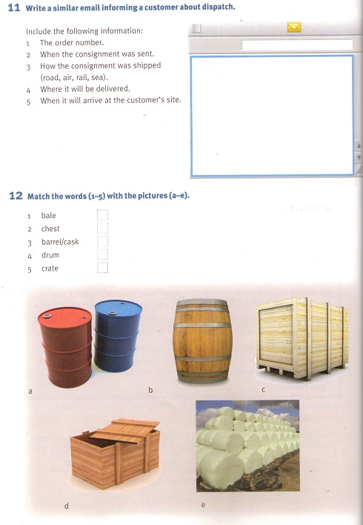

8. WAREHOUSING AND STORAGE
Warehouse equipment
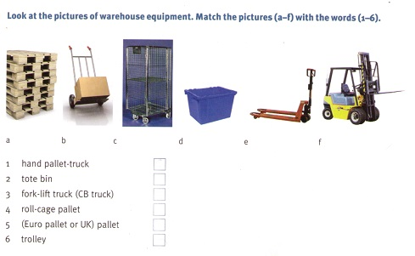
a (Euro pallet or UK) pallet d tote bin
b trolley e hand pallet - track
c roll-cagepallet f fork-lift truck (CB truck)
Warehouse areas
The receiving area. That`s where all incoming goods arrive and documentation is checked and recorded. Goods are often unpacked or repacked here to make their format more suitable for warehouse handling.
The back-up storage area holds most of our warehouse inventory.
In the order picking area the goods are selected in the right quantities, that means the quantities required by the customer. Here we also break bulk. That means, for example, after receiving goods in large quantities (e.g.pallets), we need to pack them in smaller separate units for the customer.
In the sortation area we deal with smaller order sizes. Sometimes several orders have been batched together to simplify the picking process and now need to be sorted down to individual orders.
After picking, the goods are consolidated and made ready for dispatch. Depending on the customer`s requirements the goods may be packed into cartons or cases or they are wrapped (i.e. strech- wrapping or shrink- wrapping). Some warehouses also provide special services such as labelling. This part of warehouse operations is called collation and value-added services .
The final stage in warehouse operations is the marshalling and dispatch area.
The goods are brought together to form vehicle loads and are then loaded onto vehicles for onward dispatch.

The warehouse areas and the activities that take place in them
DISPATCH goods are brought together for loading and transport
COLLATION complete orders are packed and wrapped
RESERVE STORAGE where the goods are kept until required
ORDER PICKING AND SORTATION the goods are selected and put together
in the units required by the customer
RECEIVING the goods are prepared for warehouse operations
The steps in the goods receiving process
1. After the vehicle driver has reported to the gatehouse, the vehicle documentation is checked by staff.
2. After that, staff direct the driver to an unloading bay or a parking area.
3. The goods are checked on unloading.
4. Then the packages are processed i.e. they may be labelled with bar codes.
5. After the unit load has been checked, it goes into automated storage.
6. As soon as an appropriate location has been identified by the warehouse management system, a put-away instruction must be issued.
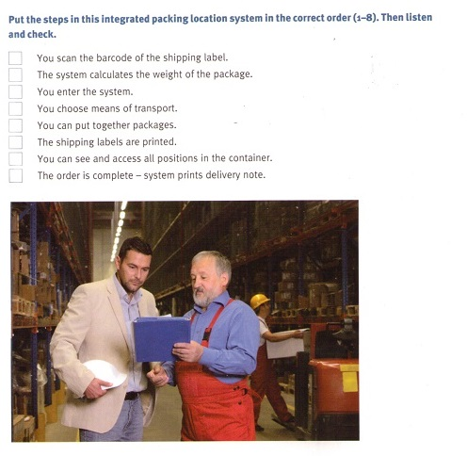
The descriptions of typical warehouse equipment and system
An automated guided vehicle is a driverless truck which is controlled by computer and electrically powered.
IBCs (intermediate bulk containers) made of metal or plastic are rigid, but there are also ones made of canvas, which are collapsible.
Cage and box pallets are fitted with corner-posts and sides . They are usually stackable.
In palletized storage APR, i.e. adjustable pallet racking, is used.
Some products are not suitable for palletization e.g. expensive electronic items or large and bulky items.
Mobile shelving is often used for smaller products in non-palletized system.
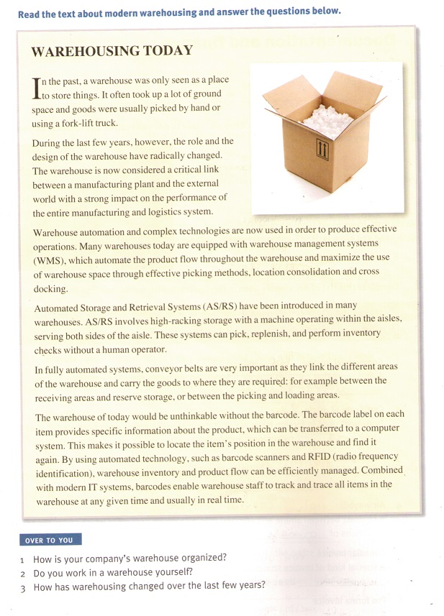

9.DOCUMENTATION AND FINANCE
Some abbreviations. They relate to documentation and finance.
B/L bill of lading
D/P documents against payement
EXW ex work
CIF cost, insurance, freight
AWB air waybill
IMO international money order
B/E bill of exchange
L/C letter of credit

Documentes used in foreign trade
COMMERCIAL INVOICE
A document that contains specific information regarding the goods shipped and the conditions agreed between buyer and saller.
CERTIFICATE OF ORIGIN
Document used in foreign trade which states where the goods were produced. It is often required by customs authorities.
PACKING LIST
A document which specifies the contents of any form of packaging, e.g. boxes, containers, cartons, without indicating the value of goods shipped. It is given to customer.
PICKING LIST
A list of materials needed to be picked. It is given to customer.
PRO FORMA INVOICE
A draft invoice which the seller prepares before the actual shipment takes place.
EXPORT LICENCE
A document which is granted by government authority and states that specified goods can be exported.
DANGEROUS GOODS DECLARATION
Certificate prepared by the shipper/consignor which states that hazardous goods are handled according to international shipping regulations.
BILL OF LADING
A contract between carrier and shipper which specifies the goods to be shipped and the delivery terms. It is also receipt of shipment and accompanies the goods until they reach their destination.
DELIVERY NOTE
A document accompanying the shipment of goods, listing the description, the quatity of goods delivered. A copy is signed by the buyer and returned to seller.

The payment methods
Advance payment
Customer /importer has to pay for the goods before they are shipped.
Cash on delivery
Customer pays immediately on receiving the goods. This service is usually provided by the post office.
Open account
The exporter supplies the goods and the importer/customer pays for them at an agreed date in the future.
Documents against payment
Also called cash against documents (CAD). It means that the exporter has full control over the documents until payment has been made by the importer.
Documentary credit
Involves the buyer`s and the seller`s bank. It is a promise made by the opening bank that payment will be made on receiving documents that comply with the terms agreed.
Bank guarantee
Used to cover financial risk in international transactions e. g. if a buyer does not pay.

