[**https://www.dailymotion.com/video/x7rn5jf**](https://www.dailymotion.com/video/x7rn5jf)

**https://ekosola.si/ekosola-meri-odtis-co2-21-22/**

**Izračun emisij CO2**

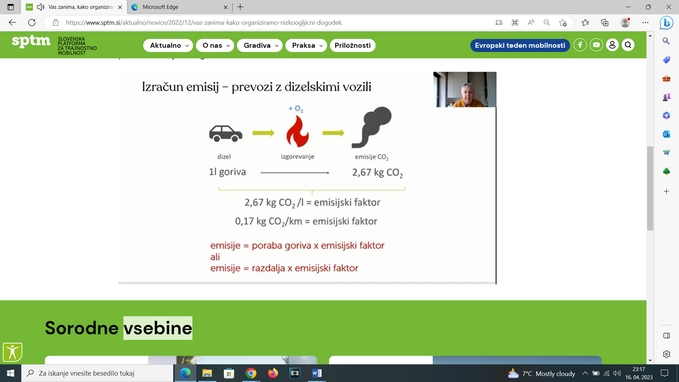

**Izračun emisij - hrana**

