**MERJENJE**

**Merjenje dolžin**

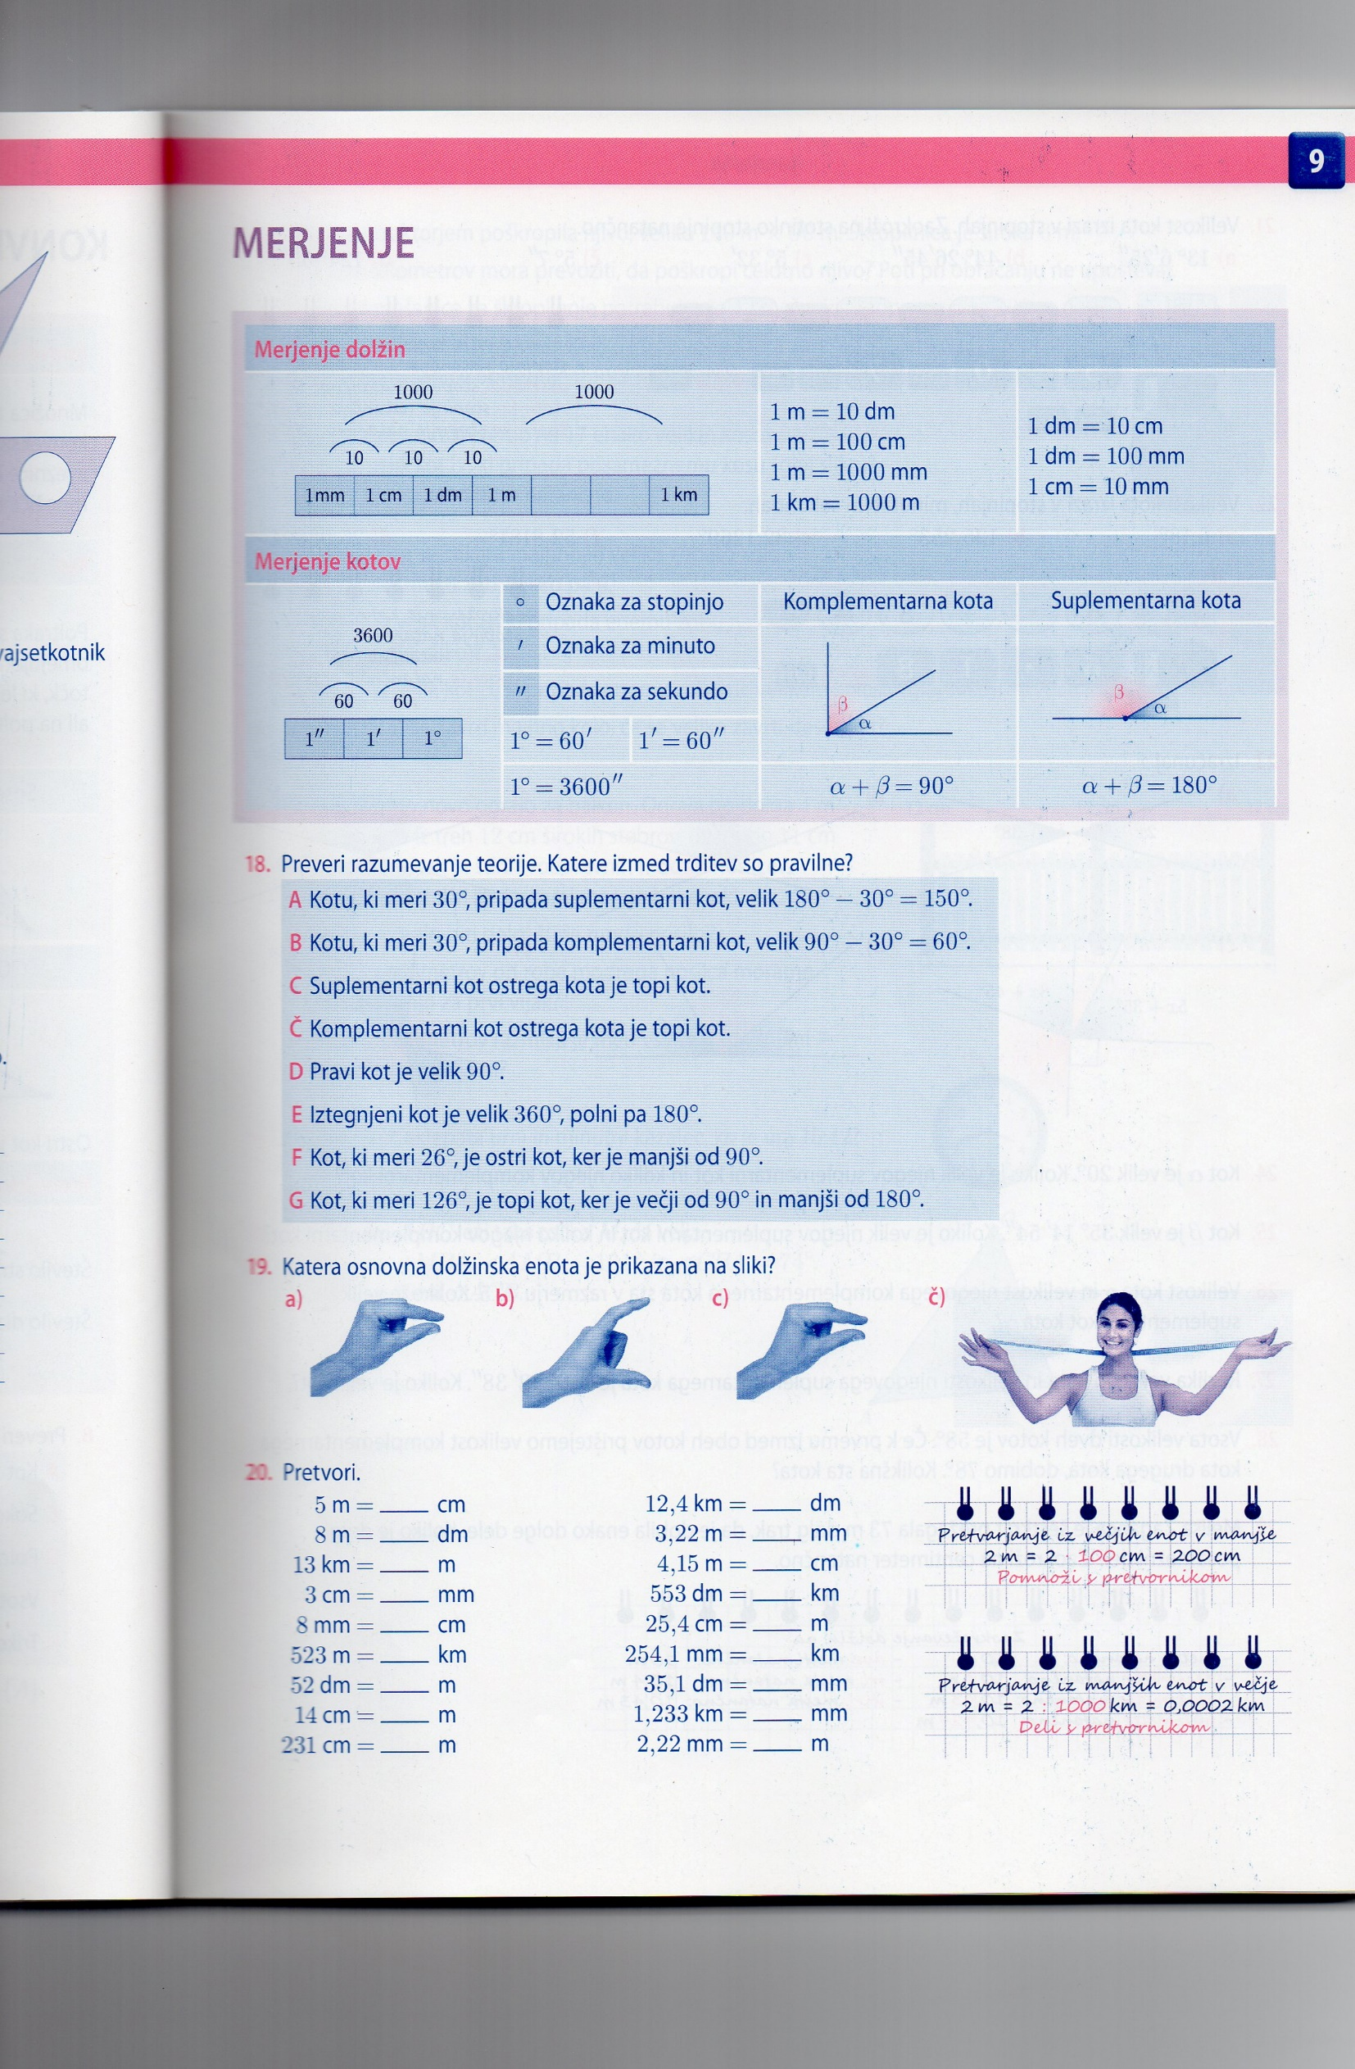

**Merjenje kotov**



        
        
        